**Experiment 4.3 (12)**

**Aryan [23BIS70108]**

**Title**

Concurrent Ticket Booking System with Seat Locking and Confirmation

**Procedure**:

Create a Node.js and Express.js application that **simulates a ticket booking system** for events or movie theaters. **Implement endpoints to view available seats**, **temporarily lock a seat for a user**, and **confirm the booking**. Design a seat locking mechanism so that **when a seat is locked, it cannot be locked or booked by other users until it is either confirmed or the lock expires automatically** (for example, after 1 minute).

**Store seat states in an in-memory data structure for simplicity**. Include clear success and error messages for different scenarios, such as trying to lock an already locked or booked seat, or confirming a seat without a lock. Test your API by simulating concurrent requests to demonstrate that the locking logic correctly prevents double booking and ensures reliable seat allocation.

**Expected Output**

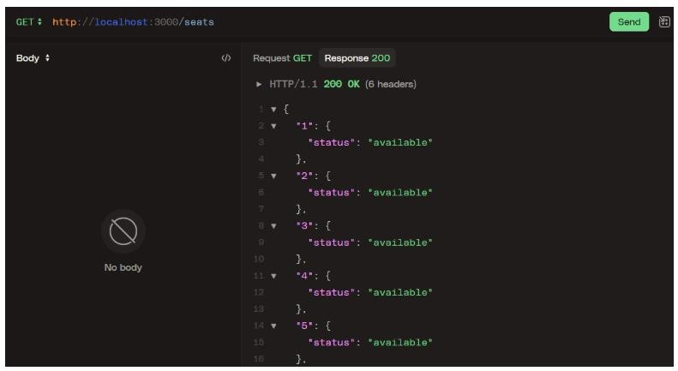

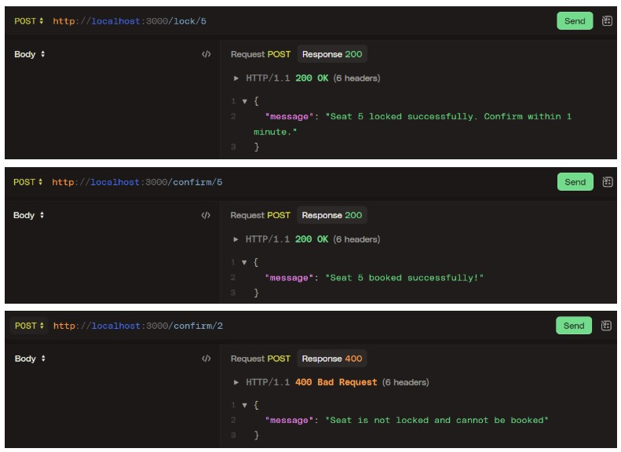



**Solution using Node.js and Express.js**

Here we require a built-in module of ES6 called **Map()** to manage the key:value pairs. It also allows to create custom properties on demand.

Here we also require built-in operator of JavaScript called delete to **delete** the custom properties

Here also required a module **uuid** to generate Unique Key Code for the values

Here we are creating a custom property called **state** having states of the seat booking like **available**, **booked**, **locked** etc.

Time is taken in millisecond for 1 minute (60*1000) millisecond

//experiment4.3.js import express from 'express';

import { v4 as uuidv4 } from 'uuid';

const app = express();

app.use(express.json());

const seats = new Map();

for (let i = 1; i <= 10; i++) {

seats.set(String(i), { state: 'available' });

}

const LOCK_DURATION_MS = 60 * 1000;

function clearLock(seat) { if (seat.lockTimeoutId) { clearTimeout(seat.lockTimeoutId); seat.lockTimeoutId = undefined;

}

delete seat.lockId; delete seat.lockedAt; seat.state = 'available';

}

app.get('/seats', (req, res) => { const result = {};

for (const [id, seat] of seats.entries()) { result[id] = { state: seat.state,

}; }

res.json(result);

});

app.post('/lock/:id', (req, res) => { const id = String(req.params.id);

const seat = seats.get(id);

if (!seat) {

return res.status(404).json({ message: `Seat ${id} does not exist.` }); }

if (seat.state === 'booked') {

return res.status(400).json({ message: `Seat ${id} is already booked.` });

}

if (seat.state === 'locked') {

return res.status(400).json({ message: `Seat ${id} is already locked.` }); }

seat.state = 'locked'; seat.lockId = uuidv4();

seat.lockedAt = Date.now();

seat.lockTimeoutId = setTimeout(() => {

// Only clear if still locked (it may have been booked)

if (seat.state === 'locked') { clearLock(seat);

console.log(`Auto-unlocked seat ${id} after timeout.`);

}

}, LOCK_DURATION_MS);

return res.status(200).json({

message: `Seat ${id} locked successfully. Confirm within 1 minute.`

});

});

app.post('/confirm/:id', (req, res) => { const id = String(req.params.id);

const seat = seats.get(id);

if (!seat) {

return res.status(404).json({ message: `Seat ${id} does not exist.` }); }

if (seat.state !== 'locked') {

return res.status(400).json({ message: 'Seat is not locked and cannot be booked' });

}

if (seat.lockTimeoutId) { clearTimeout(seat.lockTimeoutId);

seat.lockTimeoutId = undefined;

}

seat.state = 'booked'; delete seat.lockId;

delete seat.lockedAt;

return res.status(200).json({ message: `Seat ${id} booked successfully!` }); });

const PORT = 3000; app.listen(PORT, () => {

console.log(`Seat-locking server listening on http://localhost:${PORT}`); });

Test it using Postman

